MEASURING THE PULSE OF PROSPERITY:AN INDEX OF ECONOMIC FREEDOM ANALYSIS

Milestone 1: Define problem or Problem understanding

Activity 1: Specify the business problem

Economic freedom is the fundamental right of every human to control his or her own labor and property. In an economically free society, individuals are free to work, produce, consume, and invest in any way they please. In economically free societies, governments allow labor, capital, and goods to move freely, and refrain from coercion or constraint of liberty beyond the extent necessary to protect and maintain liberty itself.

For much of human history, most individuals have lacked economic freedom and opportunity, condemning them to poverty and deprivation.

Today, we live in the most prosperous time in human history. Poverty, sicknesses, and ignorance are receding throughout the world, due in large part to the advance of economic freedom. In 2022, the principles of economic freedom that have fueled this monumental progress are once again measured in the Index of Economic Freedom, an annual guide published by The Heritage Foundation, Washington's No. 1 think tank.

We measure economic freedom based on 12 quantitative and qualitative factors, grouped into four broad categories, or pillars, of economic freedom:

1. Rule of law property rights, government integrity, judicial effectiveness)
2. Government size (government spending, tax burden, fiscal health)
3. Regulatory efficiency (business freedom, labor freedom, monetary freedom)
4. Open markets (trade freedom, investment freedom, financial freedom)

**Activity 2: Business requirements**

**What Is an Index of Economic Freedom?**

An index of economic freedom measures jurisdictions against each other in terms of parameters such as trade freedom, tax burden, judicial effectiveness, and more. These factors may be weighted according to their influence on economic freedom and compiled into a single score that allows for a ranking. The ranking can be done on a country basis or can look at wider regions or smaller subnational units like states.

The most widely referenced index of economic freedom is produced by the Heritage Foundation, a conservative American think tank. The Fraser Institute, a Canadian think tank, also publishes a well-known index of economic freedom.

**Understanding Economic Freedom Indexes**

Indexes of economic freedom arose in the discipline of economics as part of New Institutional Economics, specifically from the study of the relationship between political-economic institutions and economic development. Going back at least as far as the [ideas of classical economists](https://www.investopedia.com/terms/c/classical-growth-theory.asp), such as [Adam Smith](https://www.investopedia.com/updates/adam-smith-economics/), there had been a strong streak of free-market-oriented thought in economics. Based on their observations of how economies function, economists developed theories about how political-economic institutions like free trade and the consistent enforcement of private property rights were essential to promoting economic development and general prosperity.

In the late 20th century, some New Institutional economists sought to quantify the concept of "economic freedom" that these institutions embody, so that they could use it in rigorous empirical studies to test and demonstrate the link between institutions and [economic growth](https://www.investopedia.com/terms/e/economicgrowth.asp). A major motivation of these studies was to remedy apparent failures by major contemporary [theories of economic development](https://www.investopedia.com/terms/d/development-economics.asp) to explain variation in the rate of development across different countries.

The indexes of economic freedom that these economists developed combine qualitative and quantitative data about the laws, regulations, taxes, and general economic policies of different countries (or subnational political entities) into a composite score for each country and an overall ranking across countries.

These scores and ranks can then be compared statistically with metrics of economic performance or other variables by researchers. In general, these studies have found that more economically free countries tend to also experience greater rates of investment, faster economic growth, and higher per capita incomes.

A major issue with the construction of indexes of economic freedom is the definition of the term "economic freedom," as well as how any specific policy or institution should be counted as either promoting or detracting from economic freedom. It should be noted that some of these categories are ideologically loaded.

For example, the absence of [binding minimum wage laws](https://www.investopedia.com/terms/m/minimum_wage.asp) appeals to a [laissez-faire](https://www.investopedia.com/terms/l/laissezfaire.asp) economist as a high degree of labor freedom, but might strike a liberal economist as a policy that limits the economic freedom of the workers. Even among free-market-oriented economists there are sometimes fierce differences of opinion regarding whether specific policies and institutions should be considered economically free or not.

Overall, however, despite these disagreements, the advent and application of indexes of economic freedom were influential in the 1990s and 2000s in driving economic development and public policy. The demonstrated economic benefits of economic freedom helped lead to increased openness to trade and other market-oriented reforms across developing countries, in post-Soviet Eastern Europe, and even in advanced economies.

**The Heritage Index of Economic Freedom**

The Heritage Foundation's Index of Economic Freedom is one of the most popular of these indexes. It scores countries based on 12 factors:

* Property rights
* Judicial effectiveness
* Government integrity
* Tax burden
* Government spending
* Fiscal health
* Business freedom
* Labor freedom
* Monetary freedom
* Trade freedom
* Investment freedom
* Financial freedom

A country's scores in each area are then compiled into a single score, according to which countries are ranked from most (highest score) to least free.

The Heritage Foundation's Index of Economic Freedom has pointed out some important correlations that should encourage nations to try to improve their scores over time. The most important is the observation that people living in countries categorized as free or mostly free enjoy higher incomes than those living in lower-scoring nations.

The disparity between the best and worst nations is almost 10 times, meaning that on average someone in an economically free nation makes nearly 10 times more money than someone in an economically non free nation. Related to this income gap, there is also a correlation between economic freedom and [GDP growth](https://www.investopedia.com/terms/r/realeconomicrate.asp), as well as a higher [standard of living](https://www.investopedia.com/terms/s/standard-of-living.asp) and a general rule of law for citizens.

**Recent Index of Economic Freedom Rankings**

In recent years, the top countries for economic freedom have been fairly consistent. Singapore ranked number one in 2021 with an overall score of 89.7. It was followed by New Zealand (83.9), Australia (82.4), Switzerland (81.9), and Ireland (81.4) to round out the economies rated as free. Countries on the opposite end of the freedom spectrum include North Korea (5.2), Venezuela (24.7), Cuba (28.1), Sudan (39.1), and Zimbabwe (39.1). The United States ranked 20th with an overall score of 74.8, dropping by 1.8 points from 2020 mostly due to increased trade restrictions.

As mentioned, the higher the score in the economic freedom index, the higher the income and vice versa. Countries ranked as "free" or "mostly free" had an average per-capita GDP that was double the overall average, and more than six times higher than the average per-capita incomes of "repressed" countries.

There is also a regional phenomenon where similarly ranking countries can be clustered. In 2021, Sub-Saharan Africa scored below the world average of 61.6 with a regional score of 55.7. Europe scored above the world average as a region with 70.1. Of course, there are outliers in every region. North Korea, with the overall worst score of 5.2, is in the Asia Pacific region along with two of the highest scorers—Singapore and Taiwan.

| **Top 10 Countries by Economic Freedom** | |
| --- | --- |
| Singapore | 89.7 |
| New Zealand | 83.9 |
| Australia | 82.4 |
| Switzerland | 81.9 |
| Ireland | 81.4 |
| Taiwan | 78.6 |
| United Kingdom | 78.4 |
| Estonia | 78.2 |
| Canada | 77.9 |
| Denmark | 77.8 |

**How the Index of Economic Freedom Is Used for Investing**

The Heritage Foundation's Index of Economic Freedom website features a [heat map](https://www.heritage.org/index/heatmap) that allows you to view the changes in the world over time. In addition to being academically interesting, the change to economic freedom over time can be a significant data source for investors, particularly those interested in [emerging markets](https://www.investopedia.com/terms/e/emergingmarketeconomy.asp).

The index of economic freedom can provide a guide as to whether the potential for hot emerging market picks like the [BRIC nations](https://www.investopedia.com/terms/b/bric.asp) (Brazil, Russia, India, and China) are actually seeing the policy changes necessary for that growth to benefit international investors. On the opposite end, negative changes in the index can be a signal to investors to trim their direct and indirect exposure to nations that are experiencing a decline.

## **Special Considerations**

The latest edition of the heritage index omitted two regions that had previously ranked close to the top by economic freedom: Hong Kong and Macau. Hong Kong had previously held the number one spot for 25 years, before being bumped by Singapore in 2020 due to perceptions of [tightening control](https://www.investopedia.com/why-hong-kong-needs-autonomy-to-be-a-global-financial-hub-4690553) by the mainland Chinese government.

In a note accompanying the 2021 Index, the Heritage Foundation explained that Hong Kong was left out, so that the index would only cover places "were governments exercise sovereign control of economic policies." Although both regions continue to enjoy advantageous policies, the Foundation explained, "those policies are ultimately controlled from Beijing."

Hong Kong officials objected to the omission, calling the assertion of Beijing's control "ill-conceived and untrue."

## **Index of Economic Freedom FAQs**

### How Does Political Freedom Determine Economic Growth?

Although there is a correlative relationship between political freedom and economic growth, establishing causation is less certain. One study found that countries that transitioned to a democratic government enjoyed a 20% average gain over 25 years, compared to those that retained authoritarian forms of government.

An MIT economist who co-authored the study suggested that democracies "get rid of special favors" that might inhibit economic growth. They are also more likely to invest in health and human capital, generating long-term economic gains.

How Is a Free Enterprise System Linked to Economic Freedom?

Economic freedom is a key element of [free enterprise](https://www.investopedia.com/terms/f/free_enterprise.asp), a market-based economic system in which business decisions are made with minimal government interference. Economic freedom, by giving individuals the ability to work, do business, and enter into voluntary contracts with one another, is a key element of the free enterprise system.

What Is the Human Freedom Index?

Similar to the economic freedom index, a human freedom index is a composite measure of personal, civil, and economic freedoms in different countries. The most famous [human freedom index](https://www.cato.org/human-freedom-index/2020) is jointly published by the right-wing Cato Institute and the Fraser Institute. Unlike the economic freedom index, the human freedom index also measures the freedom of noneconomic areas, such as religion, movement, and association in civil society.

What Is the Corruption Perceptions Index?

The corruption perceptions index is a composite measure of the perception of corruption in public institutions, based on expert assessments and opinion surveys. It is published by Transparency International, a nonprofit association founded by former employees of the [World Bank](https://www.investopedia.com/terms/w/worldbank.asp).6

**The Bottom Line**

The index of economic freedom is one of several metrics for comparing different economic regimes. Although the Heritage Foundation publishes the most widely-used economic freedom index, there are several institutions that publish their own versions. Each of them seeks to quantify elements such as regulation, taxation, government interference, and price controls, which represent constraints on free enterprise and market activity.

Activity 3: Literature survey

The ***Index of Economic Freedom*** is an annual index and ranking created in 1995 by [The Heritage Foundation](https://en.wikipedia.org/wiki/The_Heritage_Foundation) and [*The Wall Street Journal*](https://en.wikipedia.org/wiki/The_Wall_Street_Journal) to measure the degree of [economic freedom](https://en.wikipedia.org/wiki/Economic_freedom) in the world's nations. The creators of the index claim to take an approach inspired by that of [Adam Smith](https://en.wikipedia.org/wiki/Adam_Smith) in [*The Wealth of Nations*](https://en.wikipedia.org/wiki/The_Wealth_of_Nations), that "basic institutions that protect the liberty of individuals to pursue their own economic interests result in greater prosperity for the larger society"

Purpose

The Heritage Foundation website states that "Economic freedom is the fundamental right of every human to control his or her own labor and property. In an economically free society, individuals are free to work, produce, consume, and invest in any way they please. In economically free societies, governments allow labor, capital, and goods to move freely, and refrain from coercion or constraint of liberty beyond the extent necessary to protect and maintain liberty itself." By publishing yearly reports the foundation attempts to highlight where such freedoms do and don't exist.

The Heritage Foundation reports that the top 20% on the index have twice the per capita income of those in the second quintile, and five times that of the bottom 20%. [Carl Schramm](https://en.wikipedia.org/wiki/Carl_Schramm), who wrote the first chapter of the 2008 Index, states that cities of Medieval Italy and mid-19th century Midwestern American cities all flourished to the degree they possessed economic fluidity and institutional adaptiveness created by economic freedom.

Ratings

Since the creation of the index in 1995, the score for world economic freedom has increased, rising 2.6 points up to 2008.[[10]](https://en.wikipedia.org/wiki/Index_of_Economic_Freedom#cite_note-10) In 2011 the score had decreased from the 2008 score of 60.2 to 59.7, which represents an increase of 2.2 points since 1995. The Economic Freedom score improved for 117 countries, the majority of countries included in the index, which were mainly [developing](https://en.wikipedia.org/wiki/Developing_country) and [emerging market](https://en.wikipedia.org/wiki/Emerging_markets) economies. With the exception of [Europe](https://en.wikipedia.org/wiki/Europe) and [North America](https://en.wikipedia.org/wiki/North_America), there were increased levels of freedom recorded in all regions, with the greatest improvement shown in [Sub-Saharan Africa](https://en.wikipedia.org/wiki/Sub-Saharan_Africa). The top five "free" economies identified by the 2011 index were [Hong Kong](https://en.wikipedia.org/wiki/Hong_Kong), [Singapore](https://en.wikipedia.org/wiki/Singapore), [Australia](https://en.wikipedia.org/wiki/Australia), [New Zealand](https://en.wikipedia.org/wiki/New_Zealand), and [Switzerland](https://en.wikipedia.org/wiki/Switzerland), each scoring over 80 on the economic freedom grading scale. Since the Index was created in 1995, Hong Kong has been the top performing economy.

Methodology

The index evaluates 177 countries in four broad policy areas that affect the economic freedom, which are rule of law, government size, regulatory efficiency and open markets. It also takes into consideration some specific categories like property rights, judicial effectiveness, government integrity and tax burden. The ranking scores aspects of economic freedom between 0 and 100, with 0 meaning "no economic freedom" and 100 meaning "total economic freedom". There are twelve aspects divided into four categories.

**Rule of law**

**Property rights**

Degree of a country's legal protection of private property rights and degree of enforcement of those laws. It is divided into the following sub-factors:

1. physical property rights
2. [intellectual property](https://en.wikipedia.org/wiki/Intellectual_property) rights
3. strength of investor protection
4. risk of [expropriation](https://en.wikipedia.org/wiki/Expropriation)
5. quality of land administration

**Judicial effectiveness**

Degree of the [judiciary](https://en.wikipedia.org/wiki/Judiciary)'s efficiency and fairness, especially dealing with property laws. It is divided into the following sub-factors:

1. judicial independence
2. quality of the [judicial process](https://en.wikipedia.org/wiki/Judicial_process)

**Government integrity**

Analyzes how prevalent are forms of [political corruption](https://en.wikipedia.org/wiki/Political_corruption) and practices such as [bribery](https://en.wikipedia.org/wiki/Bribery), [extortion](https://en.wikipedia.org/wiki/Extortion), [nepotism](https://en.wikipedia.org/wiki/Nepotism), [cronyism](https://en.wikipedia.org/wiki/Cronyism), [patronage](https://en.wikipedia.org/wiki/Patronage), [embezzlement](https://en.wikipedia.org/wiki/Embezzlement), and [graft](https://en.wikipedia.org/wiki/Graft_(politics)). It is divided into the following sub-factors:

1. [public trust](https://en.wikipedia.org/wiki/Public_trust) in politicians
2. irregular payments and bribes
3. [transparency](https://en.wikipedia.org/wiki/Open_government) of government [policymaking](https://en.wikipedia.org/wiki/Policymaking)
4. absence of corruption
5. [perceptions of corruption](https://en.wikipedia.org/wiki/Corruption_Perceptions_Index)
6. governmental and civil service transparency

Activity 4: Social or business impact

Social impact:

There’s a mounting need for business growth that’s inclusive, responsible and lasting. This requires a measure of business success that goes beyond financials.

Our Total Impact Measurement and Management (TIMM) framework provides a new language for decision making. Instead of relying on shareholder return alone, it incorporates and values a number of non-financial impacts. It’s a holistic view of what businesses need to understand risk, identify opportunities and maintain a positive impact on society.

We’re helping companies to recognize their overall contribution, to understand the balance between the positive and negative impacts generated across their infrastructure and supply chains. By valuing social, environmental, and economic impacts, business leaders are now able to compare the total impacts of their strategies and investment choices.

Business impact **What is Business Impact?**

Business Impact is the benefit realized from a project or initiative expressed in terms of taking action vs. doing nothing.

**Why do we quantify Business Impact?**  
Ultimately, we quantify impact because we are crafting a story of how a clearly defined business objective—with prescribed actions and desired outcomes—creates value for our clients. We quantify impact to share those stories with our clients and with the world.

**How do we quantify Business Impact?**  
Business Impact should be quantified in one of the 3 primary impact categories listed below. At the start of an engagement, we speculate on what impact we will create through the project, and then we go about proving that with data and customer feedback to determine the actual results realized from the actions we took.

**How do we measure Business Impact?**

At Search Discovery, we measure Business Impact using a 4-step process.

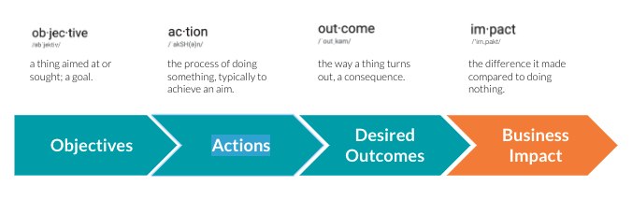

**Step 1: Define Objectives**  
Objectives are the things that we are working to achieve. These typically come from discovery discussions with stakeholders.

* **Example Objectives include**: Achieve accuracy in Analytics data, automate process, Build Brand Awareness, Enable Optimization, Faster page load times, Implement/Test/Deploy Adobe Launch, Train users on Google Analytics, etc.

**Step 2: Identify Actions**  
Actions are the specific tasks we undertake in order to accomplish our Objectives. These are identified in our Project Planning documents and are usually broken down into phases.

* **Example Actions include**: Conduct stakeholder interviews, gather business requirements, integrate data sources, harmonize data, build custom dashboards, Configure Analytics setup, incorporate new campaign requirements, Conduct training sessions, etc.

**Step 3: Document Desired Outcomes**  
Desired Outcomes are measurable targets that are directly tied to Objectives and Actions. This is where you articulate the outcomes of the project, or in other words, what you hope to achieve.

* **Example Desired include**: Improved data transparency across marketing and operations, Real-time performance monitoring, Reduced report creation time, develop internal capability to manage Adobe Launch, Establish clear metrics for success, etc.

**Step 4: Quantify Business Impact**  
Business Impact should be quantified in one of the 3 primary impact categories listed below. At the start of an engagement, we speculate on

what impact we will create through the project, and then we go about proving that with data and customer feedback to determine the actual results realized from the actions we took.

* Make Money / Save Money
* Capability / Resource / Operational Improvements
* Improved Customer / Employee Experience

Milestone 2: Data collection & extraction from database

Activity 1: Collect the dataset

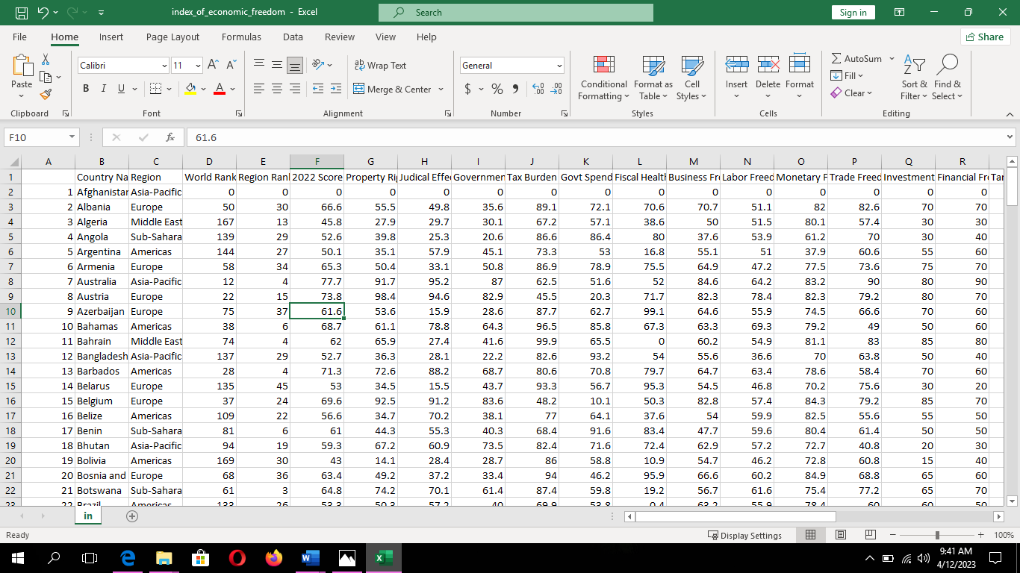

Activity 2: storing data in DB & perform SQL operations

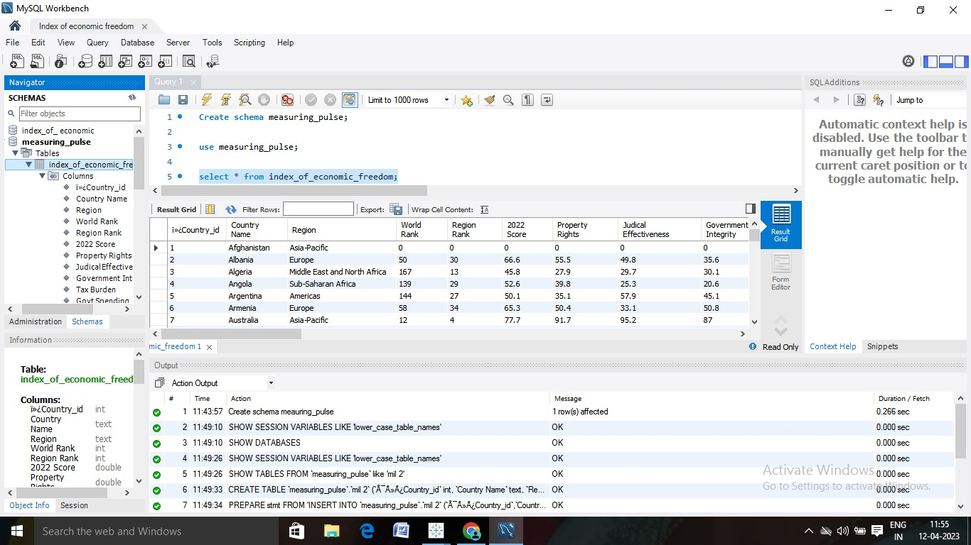

Activity 3 : connect DB with Tableau

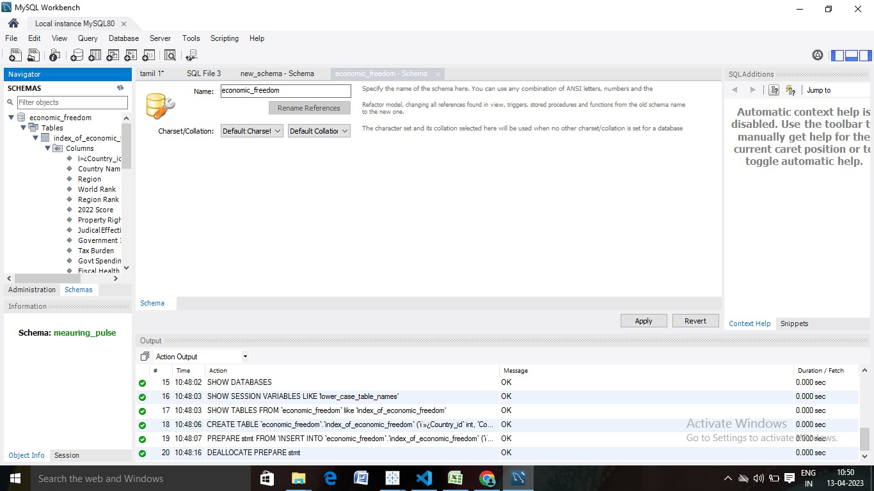

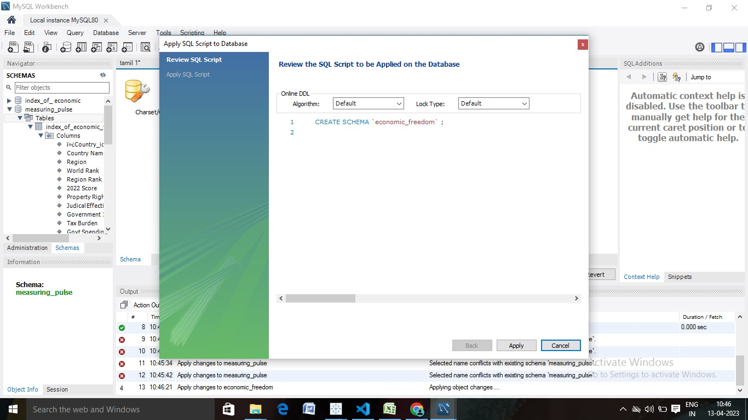

Milestone 3:Data preparation

Activity 1:Prepare the data for visualization

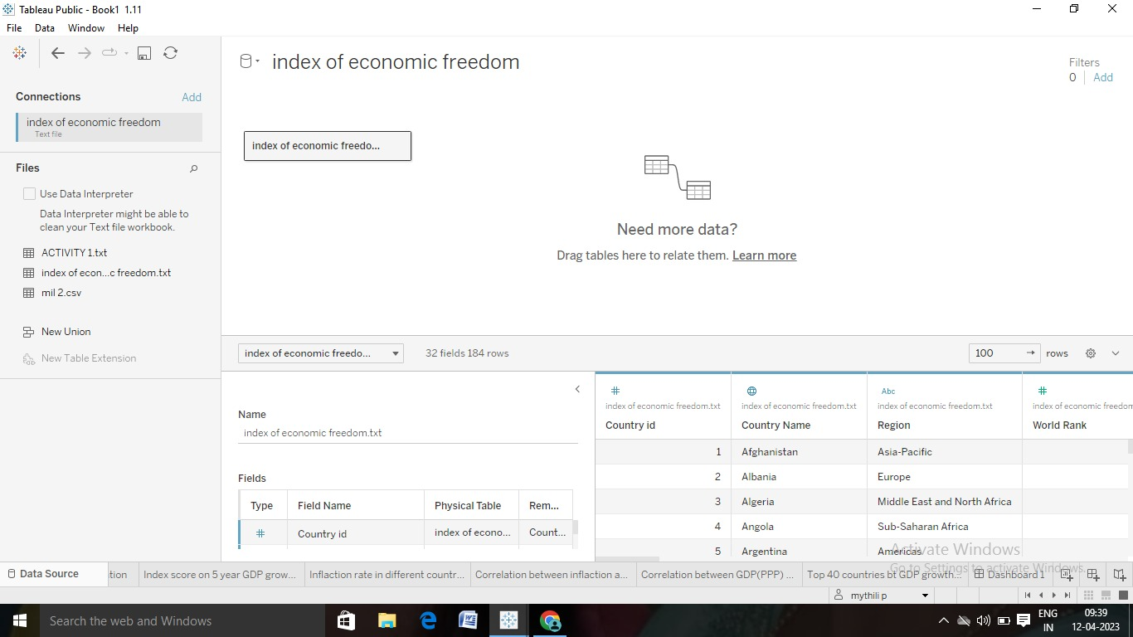

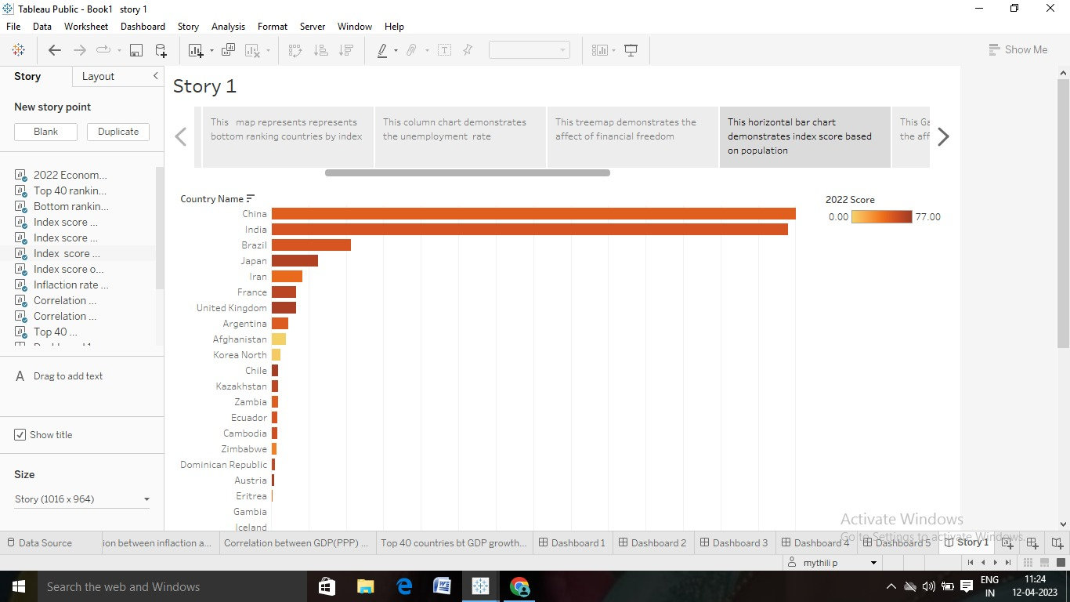

Milestone 4: Data visualization

Activity 1: Prepare the data for visualization



Milestone 4: Data visualization

Activity 1: No of unique visualizations

Activity 1.1:2022 Economic freedom score

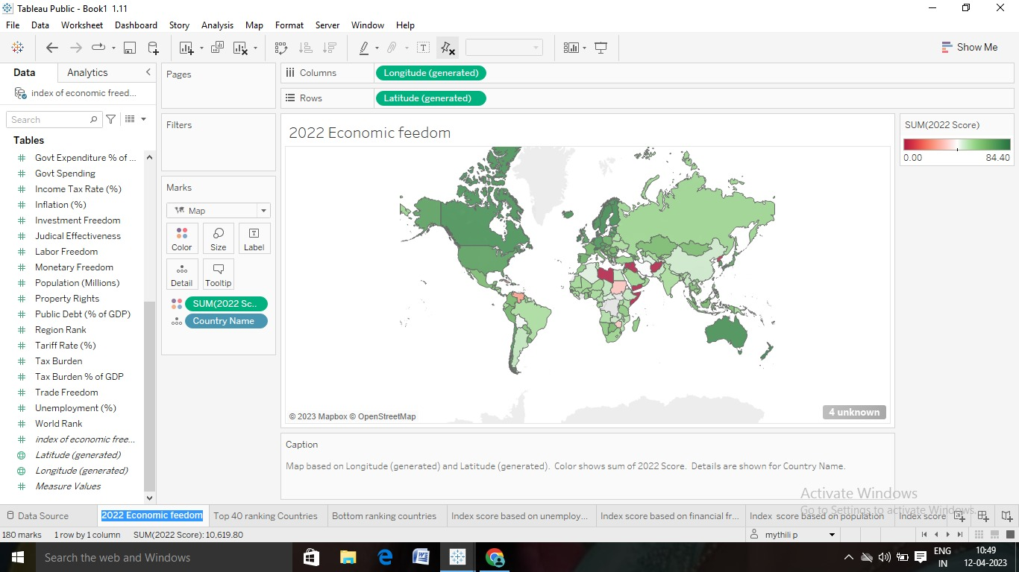

Activity 1.2: Top 40 ranking countries in the index

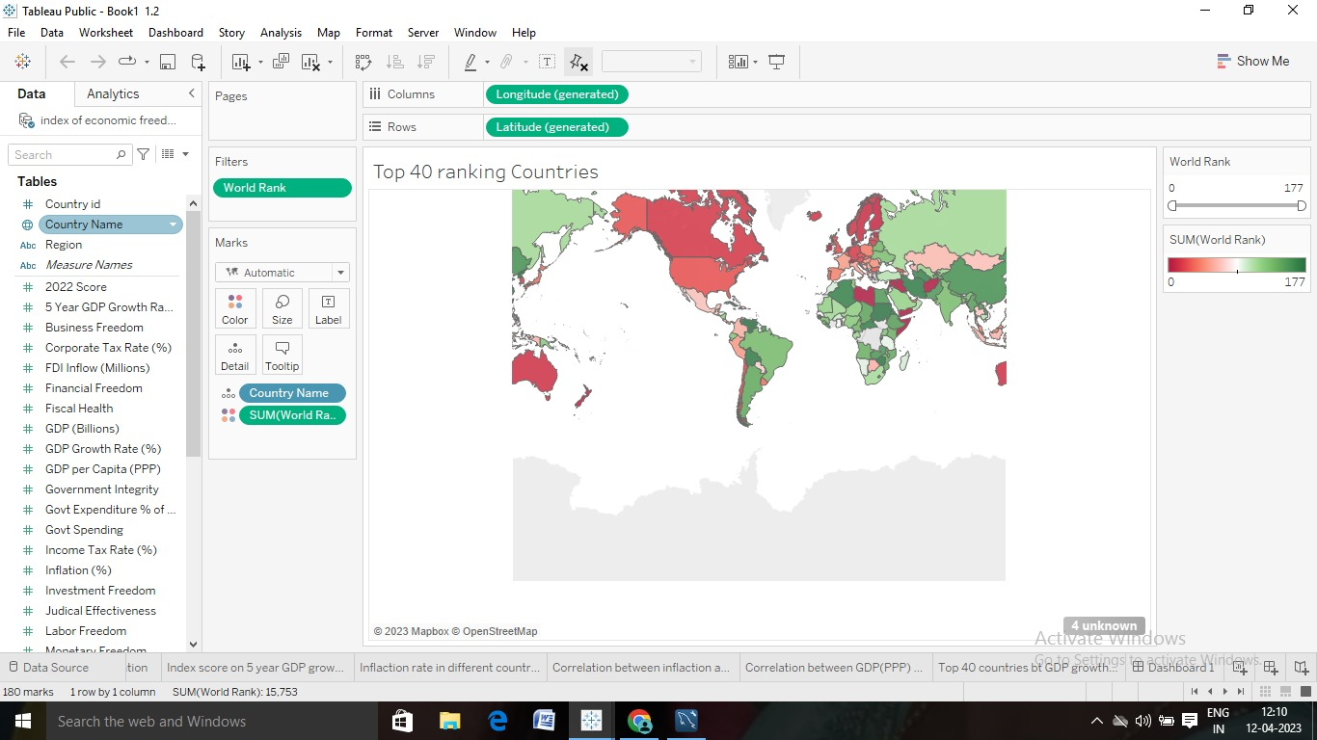

Activity 1.3: Bottom ranking countries by index

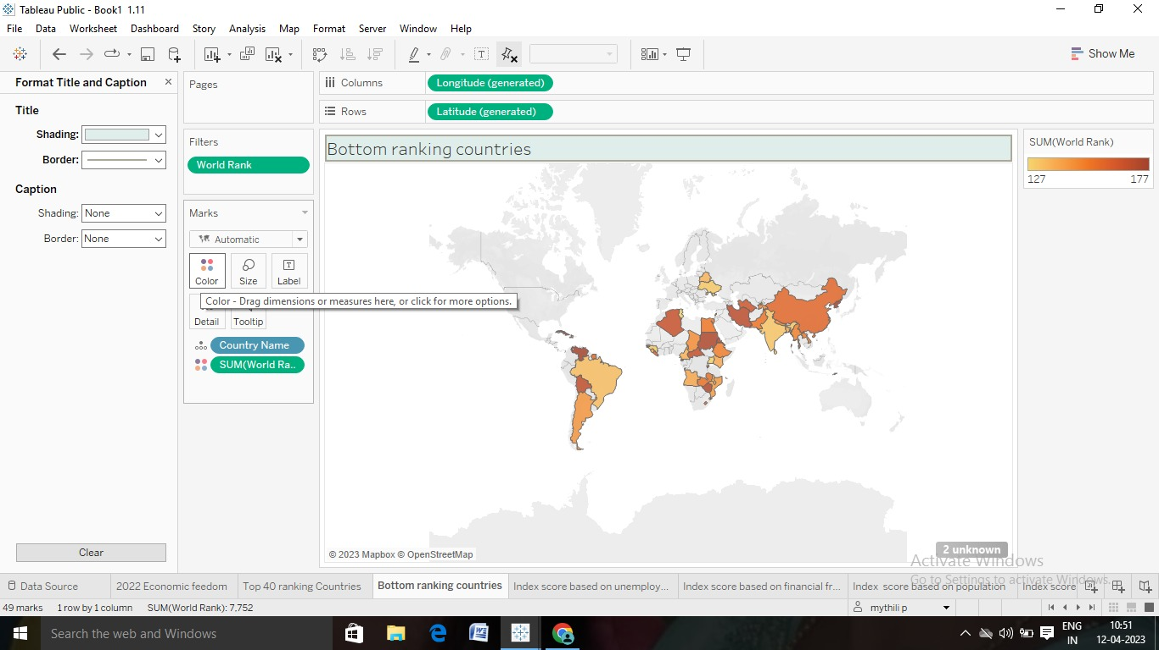

Activity 1.4: Index score based on unemployment rate

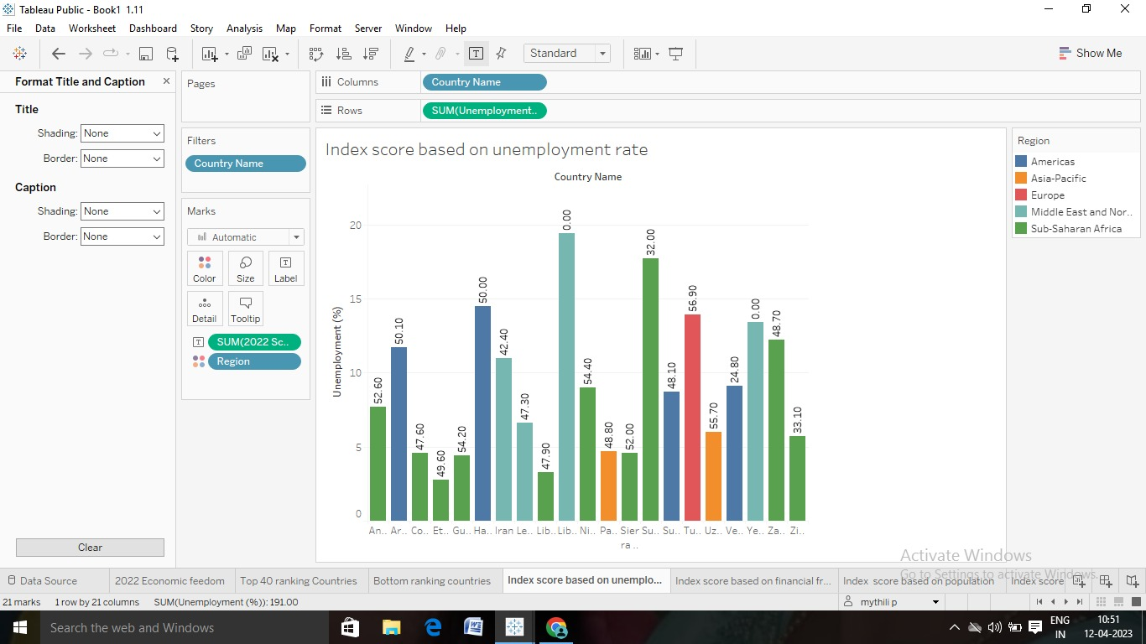

Activity 1.5: Index score based on financial freedom

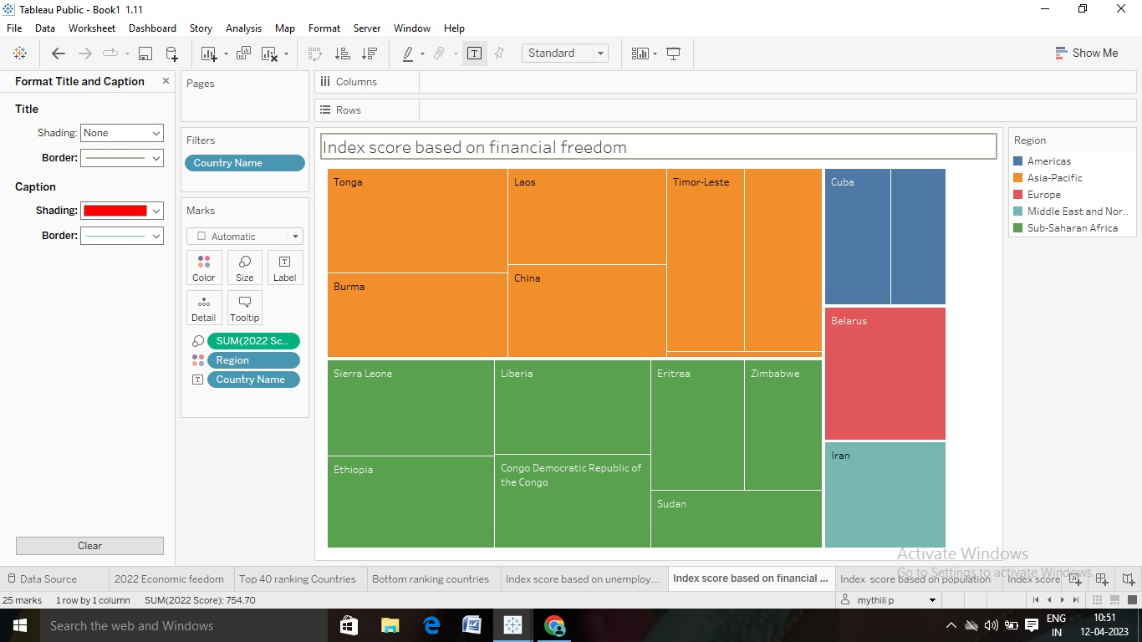

Activity 1.6: Index score based on population

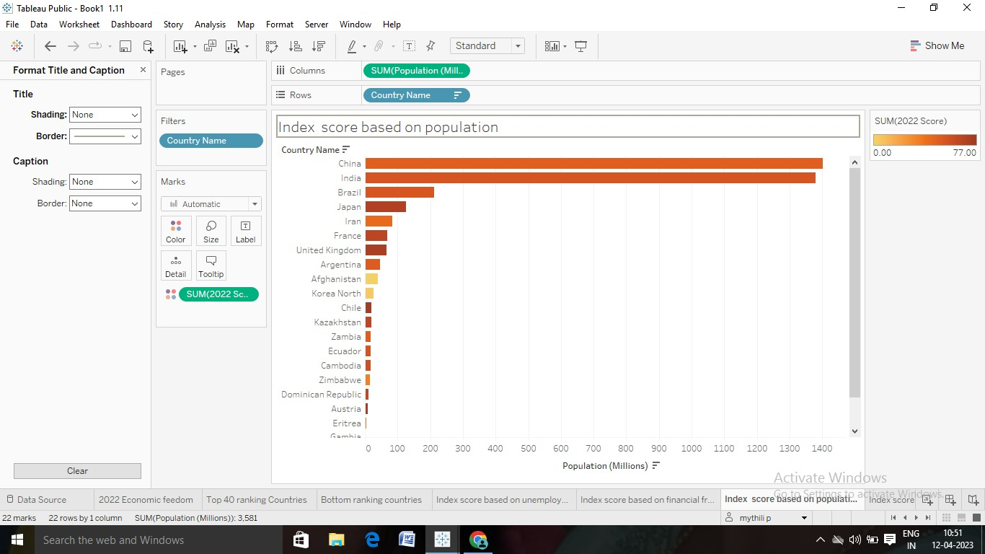

Activity 1.7: Index score based on 5-year GDP growth rate (%)

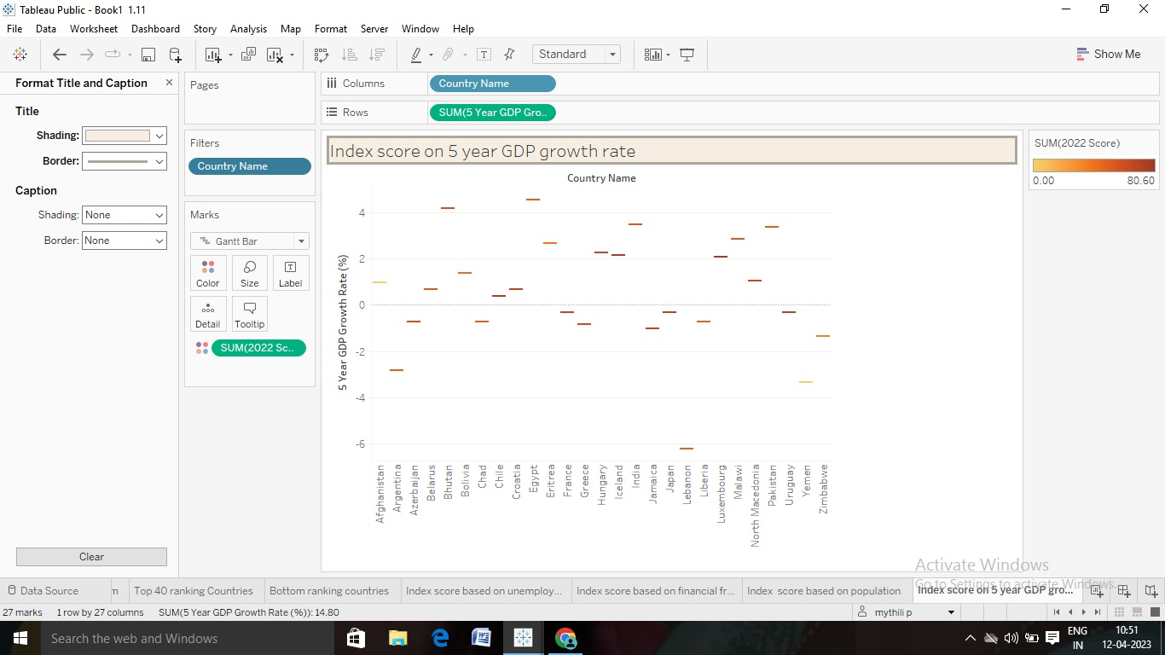

Activity 1.8: Inflation rate in different countries

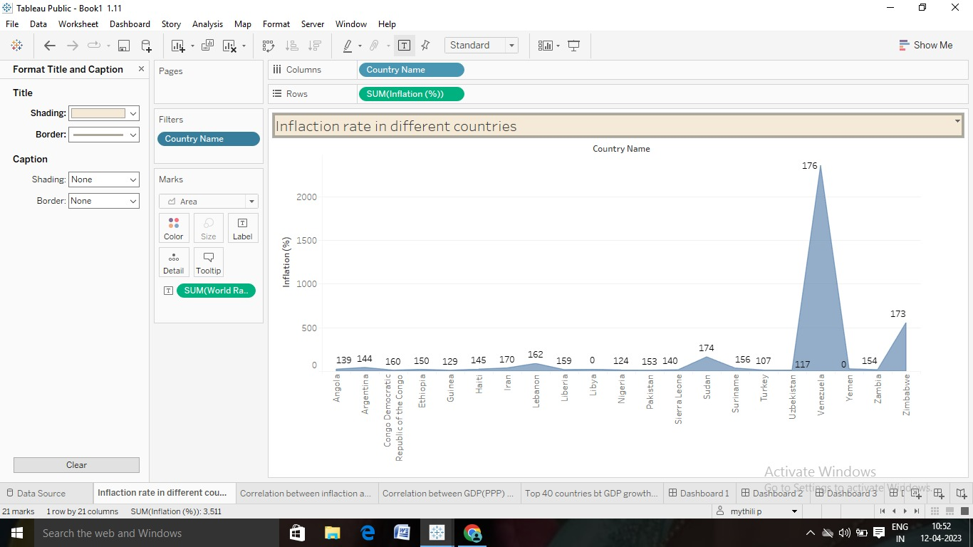

Activity 1.9: Correlation between inflation & unemployment

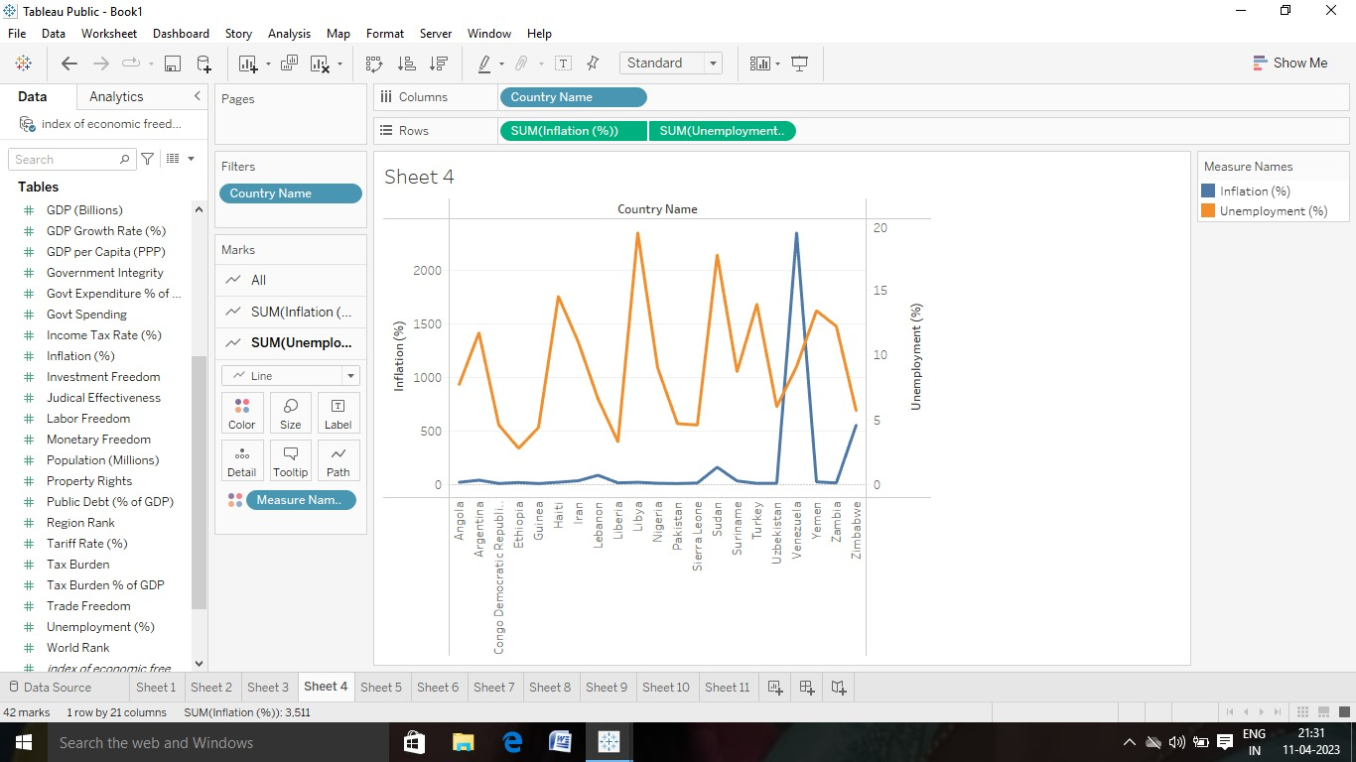

Activity 1.10: Correlation between GDP(PPP)& Monetary freedom

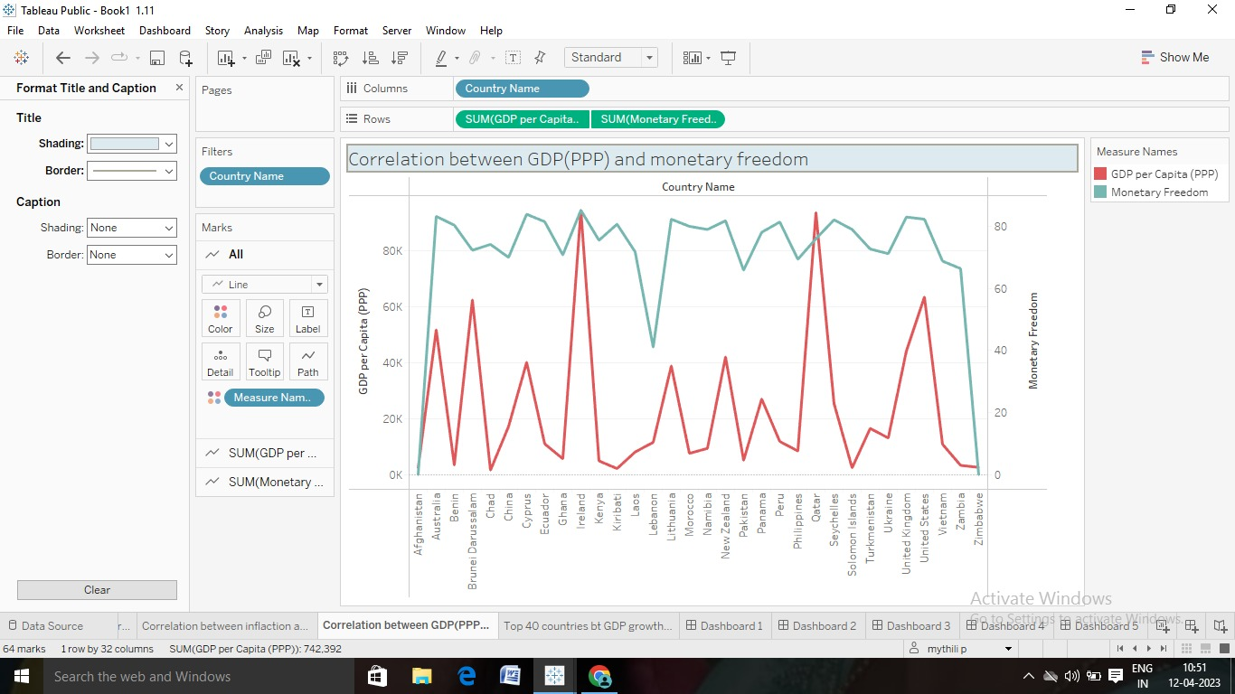

Activity 1.11: Top 40 countries by GDP growth rate

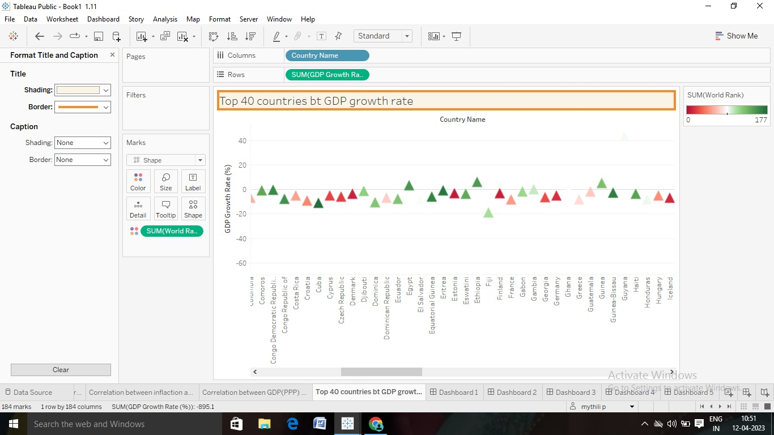

Milestone 5: Dashboard

Activity 1: Responsive and design of dashboard

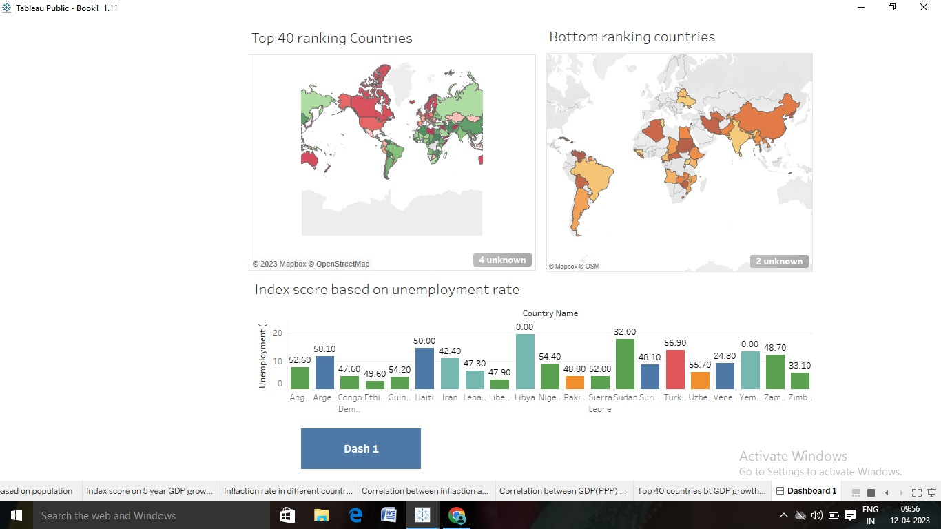

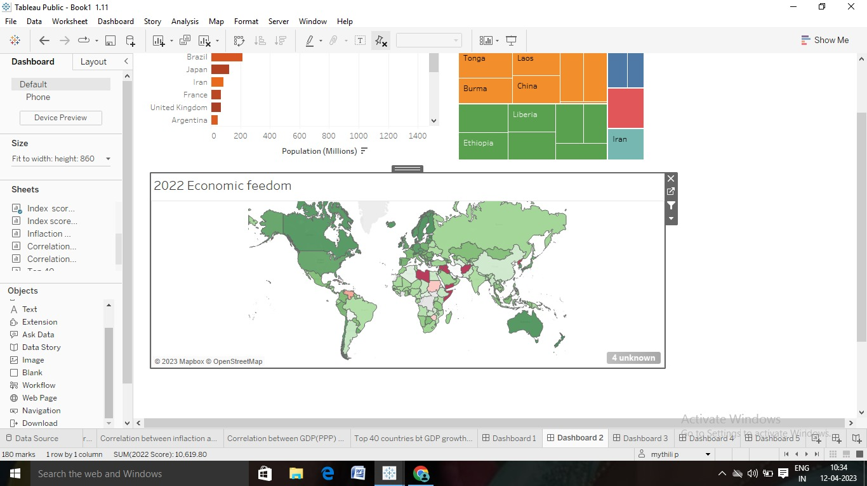

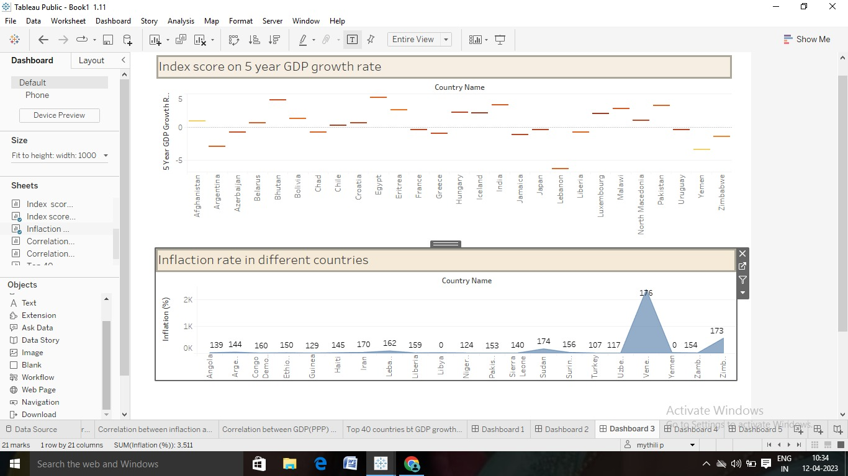

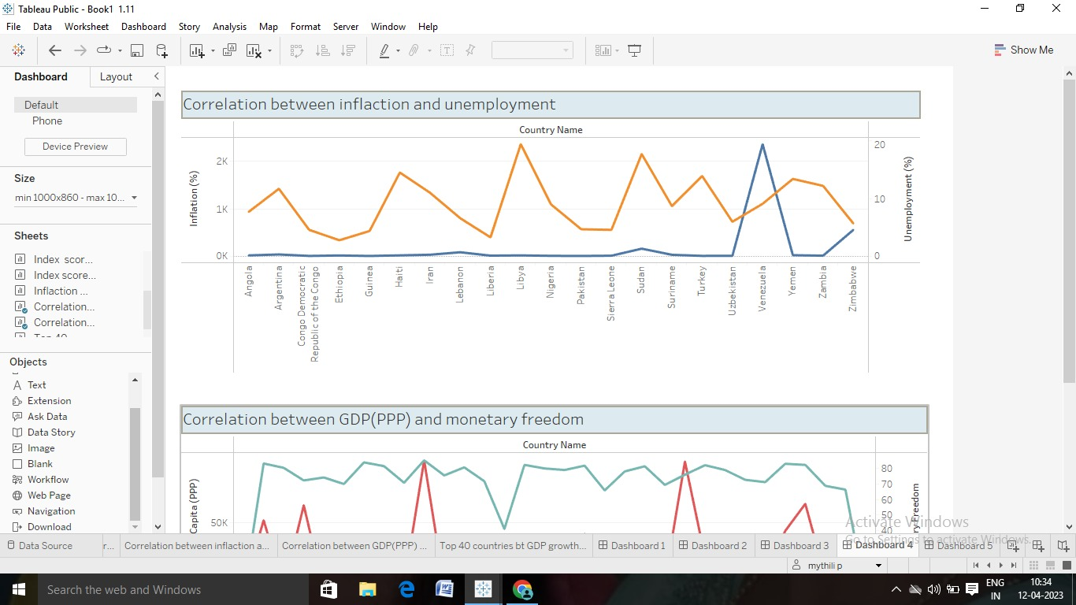

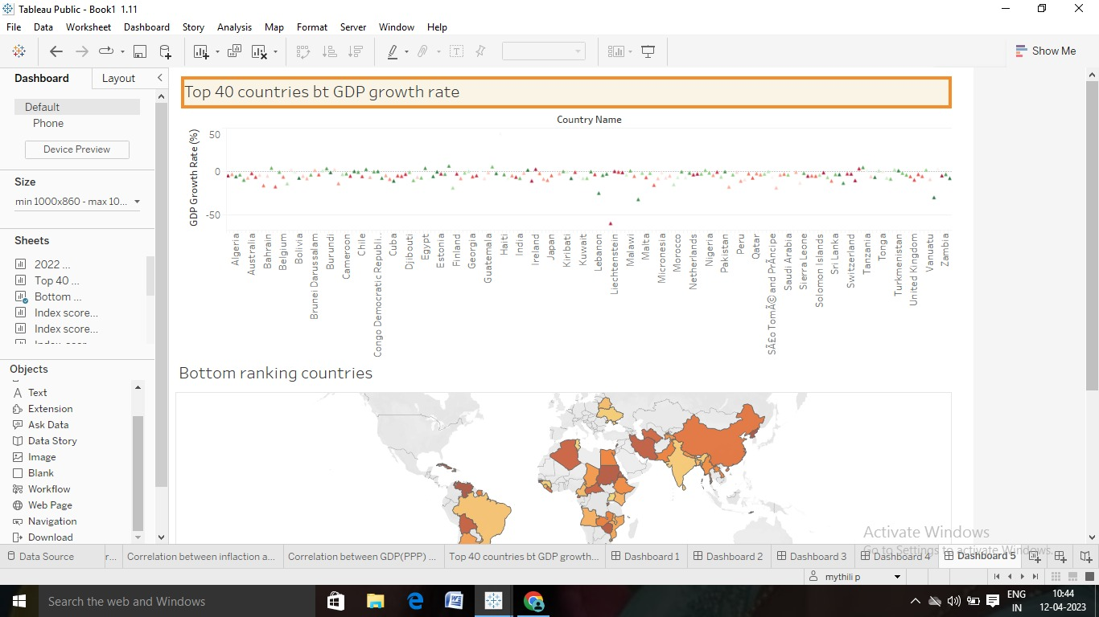

Milestone 6: Story

Activity 1: No of scenes of story

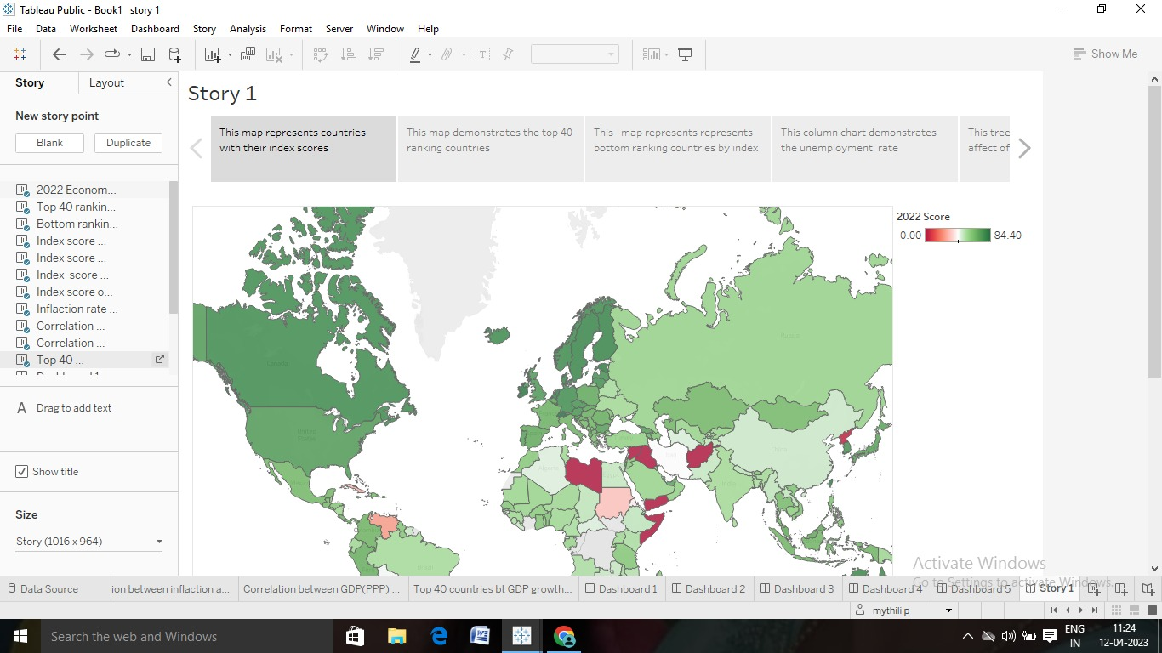

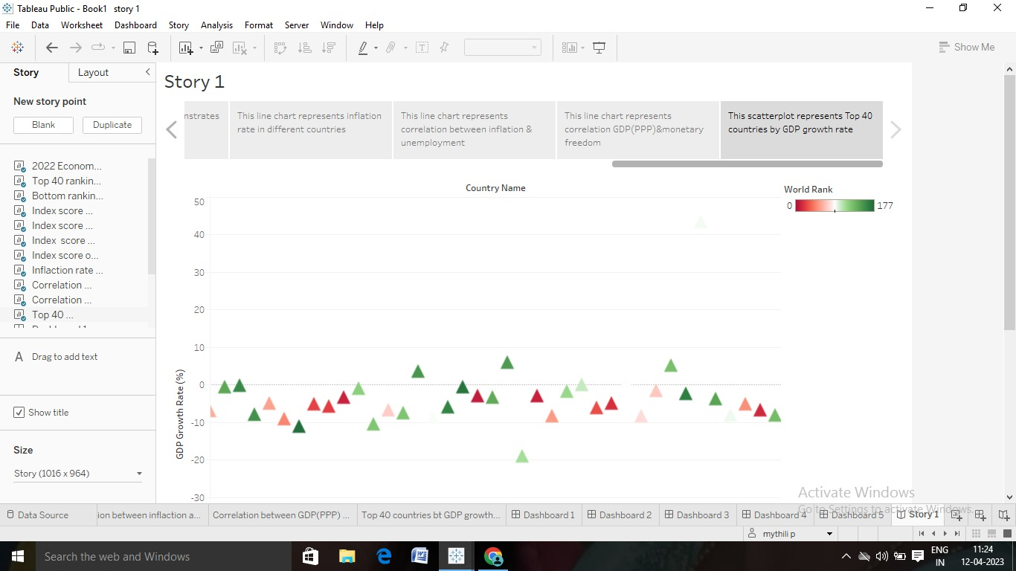

Milestone 7: performance testing

Activity 1: amount of data rendered to DB 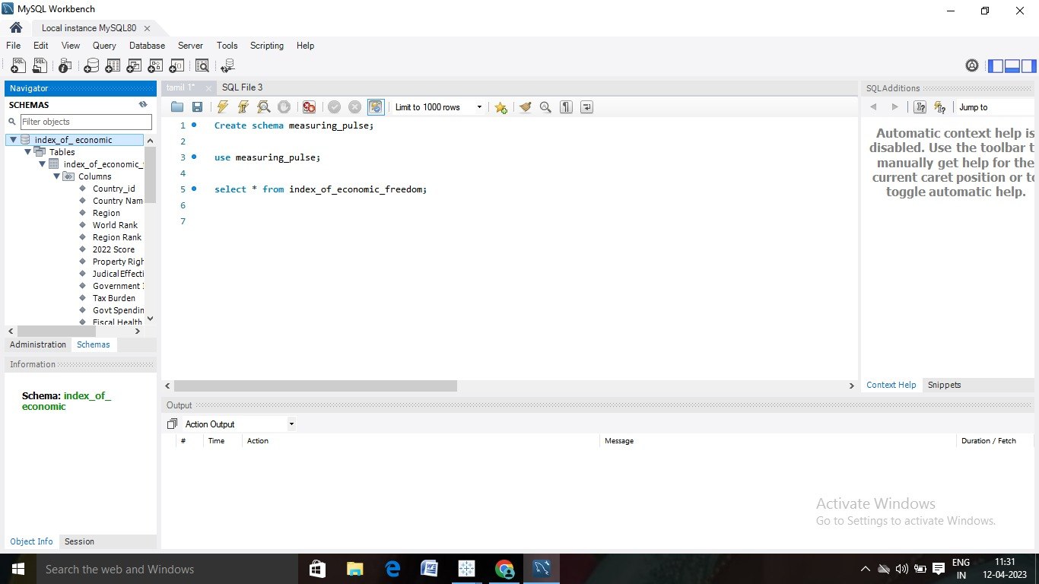

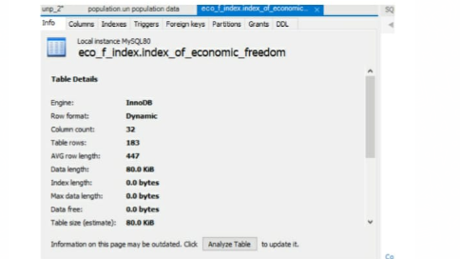

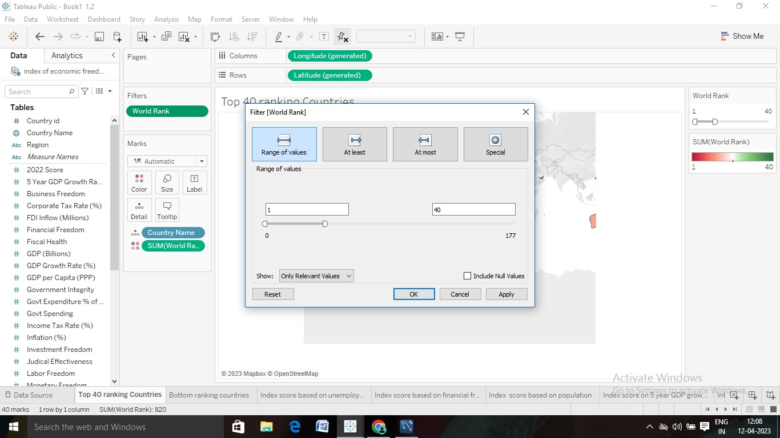

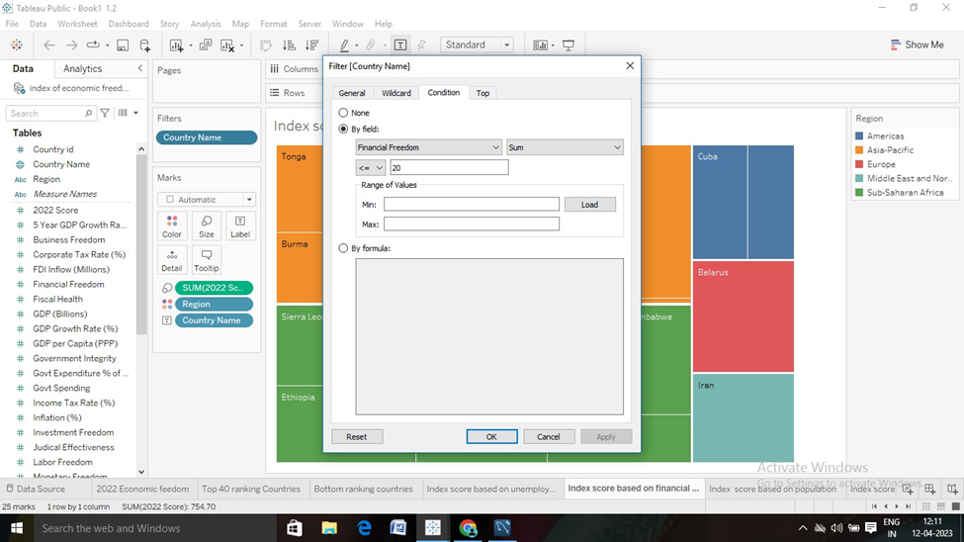

Activity 3: No of calculation fields



Activity 4: No of visualization graphs

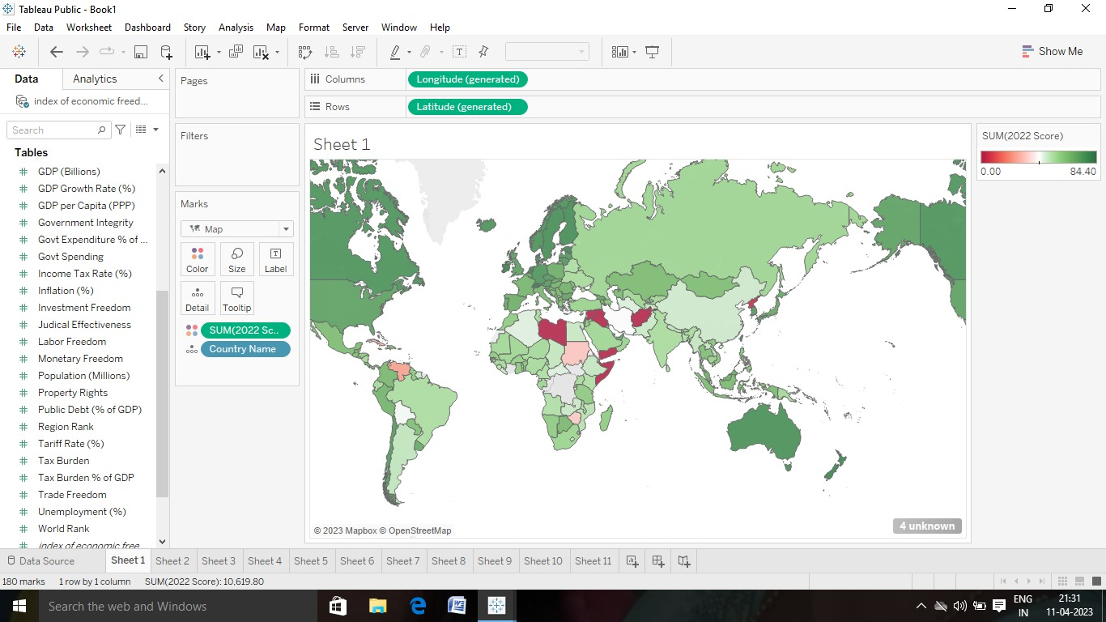

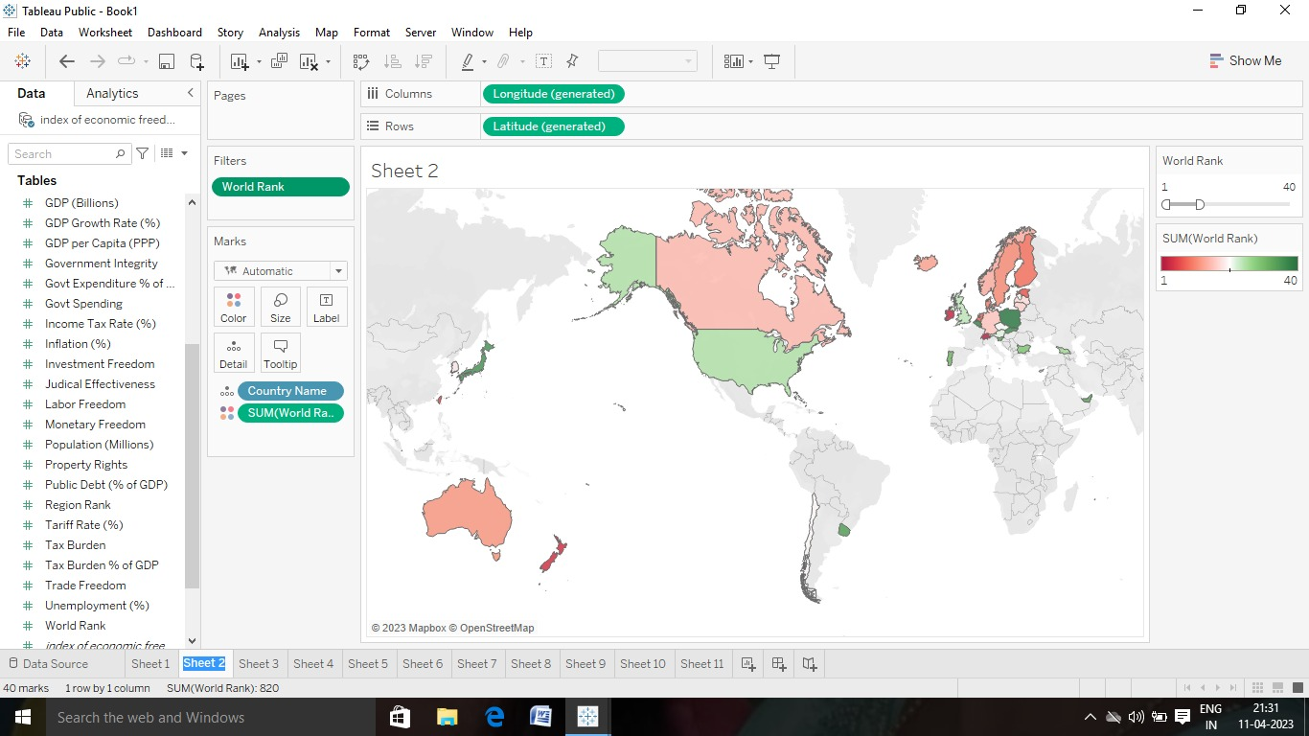













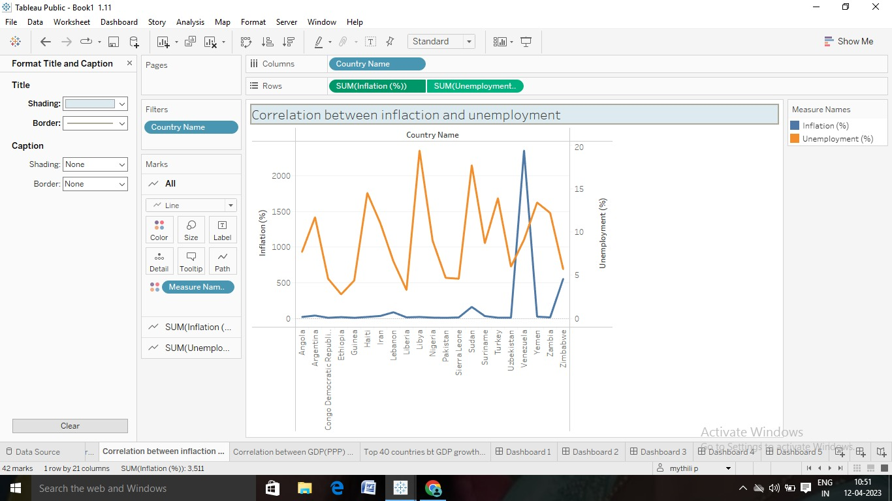





Milestone 8:

